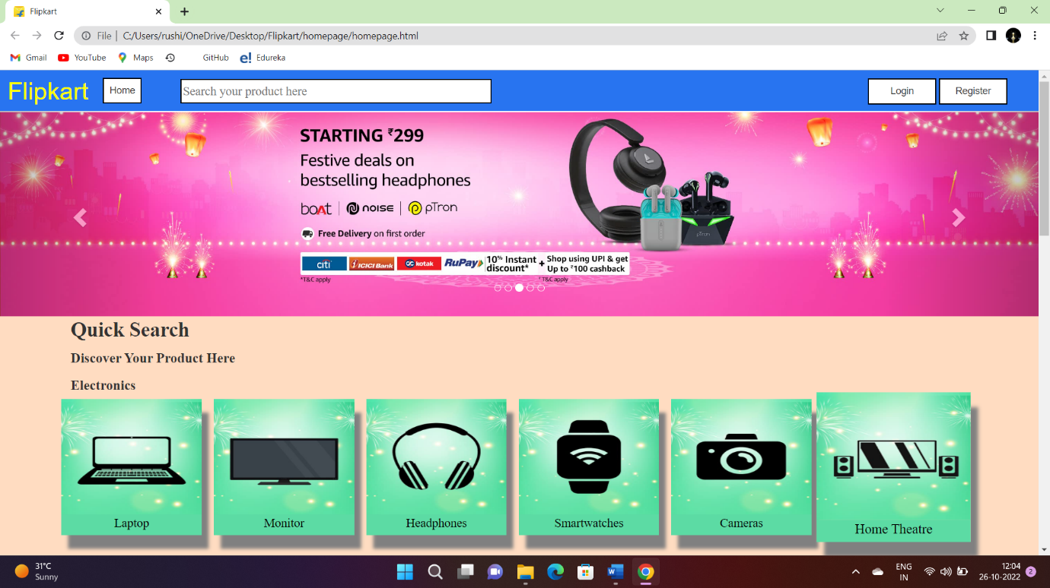**Project Name -: E-commerce Site (Flipkart)**

**Introduction / Overview -:**

Flipkart is a website that brings together the consumer and the seller so that the consumer can get what he needs at a low cost and in a short time, and the seller does not need to find a customer.

**Module -:**

[**Home Page -:**](https://mrrushikesh.github.io/homepageFlipkart/)

Homepage will be the first page of the website where the user will see the website name, search section, login and registration options in the header, there will be a carousel below the header, with the help of which the customer will get information about the trending offers, the option of quick search will remain below the exact carousel and below that there will be a footer section.

* Header -: Name, Home, Search Bar, Login & Registration > Carousel > Quick Search > Footer

[**Listing Page -:**](https://mrrushikesh.github.io/listingpageFlipkart/)

The listing page will be the second page of the website. The beginning of this page will be the header section and then the page will be divided into two sections. The left side will have a filter section and the right side will have short details of the product and the bottom section will have a footer section.

* Header > Filter > Product list > Footer

**Details Page -:**

The details page will be the third page of the website and on this page, there will be information about the product in detail, after that information there will be an order button, by clicking on the button the user will go to the order page.

* Header > Product Details > Order Button > Footer

**Order Page -:**

This will be the last page of the website where the user will fill in the order details and confirm the order of the product.

* Header > Order Details -: Customer details, Address details &Payment Option > Confirm order

**Technology Used -:**

Front End -:

HTML

CSS

JavaScript

Bootstrap

Back End -:

Nodejs + Express

Reactjs

Database -:

MongoDB

**Bibliography -:**

[www.w3school.com](http://www.w3school.com)

[www.amazon.com](http://www.amazon.com)

[www.flipkart.com](http://www.flipkart.com)

[www.edureka.com](http://www.edureka.com)